Student Information Handbook for GED & ESL
Rev. January 2022


Table of Contents
MCC COVID-19 Policy 5
MCC Campus Locations 6
Fort Omaha Campus 6
Fremont Campus 6
North Express 7
South Express: MAIN CAMPUS FOR ADULT EDUCATION 7
Adult Education Program Contacts 8
Student Services 8
IT Helpdesk 8
IET Program Facilitator – Sheila Keller 8
Adult Education Specialist – Charity Kaufman 8
GED Program Facilitator - Bob Nikunen 8
GED Program Facilitator - Karen Dean 8
ESL Program Facilitator - Kristin Broyhill 9
Adult Education Transition (CASAS Testing) Coordinator - P.J. Arellano 9
Adult Education Manager - Shannan Garcia 9
Online Educational Resources 9
MCC MyWay 9
AZTEC-GED ONLY 9
GED.com 9
ThinkCERCA - (GED Students only) 10
Burlington English- (ESL Students only) 10
NorthStar 10
Password Station 10
MCC Sessions and Class Schedules 11
Calendar for Adult Education 2022 11
Special Program Schedules 12
Computer Literacy Classes 12
NorthStar Computer/Digital Literacy Classes 12
GED Program 13
Testing Requirements of the GED Program: 13
How CASAS testing works 14
GED Ready 15
GED Official 15
ESL Program 16
Requirements of the ESL Program: 16
How CASAS testing works 16
Accelerated GED Program 17
Learning Labs 17
Training—MCC’s Integrated Education and Training Programs (IET) 18
IET Program Contacts 19
Advanced ESL 20
Language Labs 20
Open Enrollment and Class Registration 21
Late Enrollment 22
Transferring Courses 22
Attendance Policy 23
Attendance Verification for In-person Classes 24
Attendance Verification for Online/Zoom Classes 24
How to Check Email 25
Testing – Scheduling a Test 26
How to Book a CASAS Test 26
CASAS FAQ 28
GED Vouchers: 28
Taking the GED Test 29
After GED Testing 29
What to do After Program Completion 29
Continuing with MCC to an Accredited Academic Program 29
Inclement (Bad) Weather and Campus Closures 31
Disability/Accessibility Services 32
South Campus 32
Fort Omaha Campus 32
Laptop or Hotspot Loaner Program 32
Pass to Class--Free Bus Ride Program 32
Career Services 32
MCC Tutoring Center 32
MCC Language and Literacy Center 32
MCC Math Center 32
Frequently Asked Questions 33
Should I take an in-person or remote class? 33
I have a busy work schedule and family; can I just attend classes once a week? 33
Where do I find jobs or training programs? 33
What score do I need to pass ESL? 33
Do I have to pay for tests? 33
What score do I need to pass my GED? Is the GED one big test? 33
What test score is ‘college ready’ for a GED/ESL? 34
Are GED Classes like high school classes? 34
Can I bring my children? 34
Can I bring a family member or friend to ‘try out’ a class? 34
Is there a place to help with my English conversation skills? 34
Can I bring my emotional support animal? 34
If I can’t get a hold of my instructor, who should I contact? 34
Is there a graduation ceremony? 34
What supplies do I need? 35

MCC COVID-19 Policy
Masks must be worn while in MCC buildings, including throughout class sessions.
MCC Website for COVID Procedures
If you have tested positive, please fill out the Covid 19 Reporting Form.
After you fill out the online form, an MCC employee/contact tracer will tell you when you can return to class. Until you hear from this person, DO NOT go to class.
COVID FAQs are also located on the MyMCC webpage.


MCC Campus Locations

Fort Omaha Campus (FOC)
- Address: 5300 North 30th Street, Omaha, NE 68111
- Crossroads: North 30th Street and Sorenson Parkway
- Building: CAET (#24)
- Abbreviation: FOC and/or CAET
- Phone: 531-622-5231
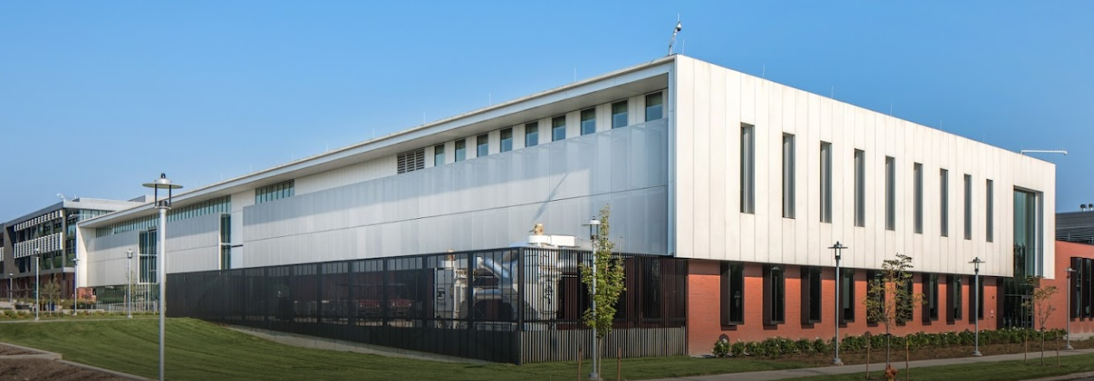
- Hours: M-R: 7:30am-7pm, F: 7:30am-5pm, S: 8am-noon

Fremont Campus
- Address: 835 N. Broad St., Fremont, NE 68025
- Crossroads: Broad Street (Hwy 77) and West 8th Street (Parking access on North H St)
- Building: Fremont Area Center
- Abbreviation: FRC
- Phone: 531-622-3000
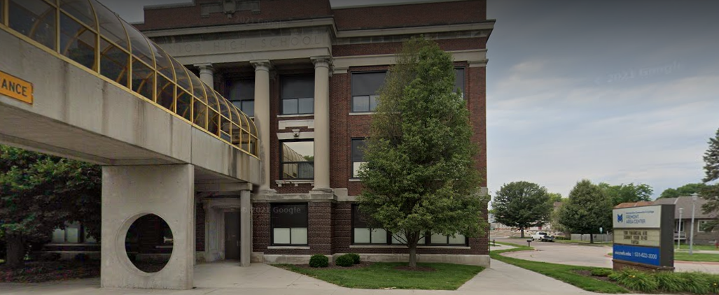

North Express (MXN)
- Address: 2112 N. 30th St., Omaha, NE 68111
- Crossroads: North 30th Street and Lake Street
- Building: Highlander Accelerator Building (3rd Floor)
- Abbreviation: MXN
- Phone: 531-622-5000
- Hours: M-Th: 8:30 am-9:00 pm, F: 8:30 am-1:00 pm
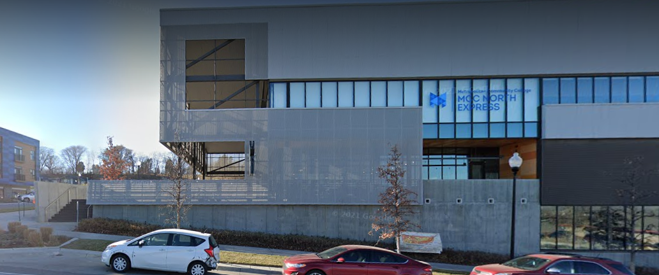

South Express (MXS): MAIN CAMPUS FOR ADULT EDUCATION
- Address: 3002 South 24th Street, Omaha, NE 68108
- Crossroads: South 24th Street and Vinton Street
- Building: North end of strip mall
- Abbreviation: MXS
- Phone: 531-622-2700
- Hours: M-Th: 8:30 am-9:00 pm, F: 8:30 am-1:00 pm

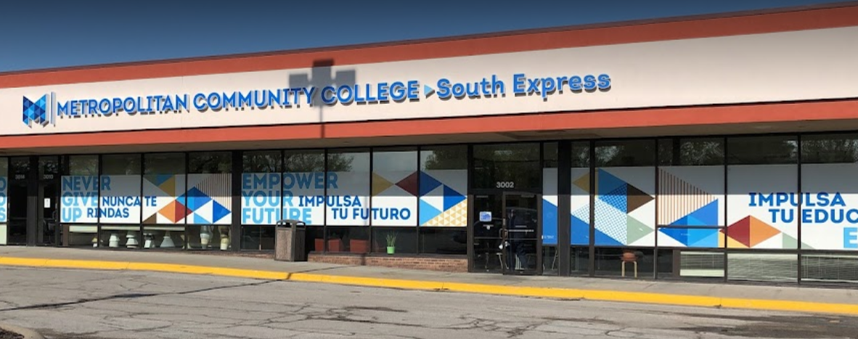

Adult Education Program Contacts
Your primary contact will be your instructor, but here are some other helpful contacts.
If you cannot contact your instructor, contact the Program Facilitator.

Student Services
- MXS Phone: 531-622-4060
- Test Reservations
- TLC Information
- General Class Information
- Community Resources

IT Helpdesk
- Email: ITSupportServices@mccneb.edu
- Phone: 531-622-2900
- MCC Email
- Passwords
- MyWay Issues

IET Program Facilitator – Sheila Keller
- Email: skkeller@mccneb.edu
- Phone: 531-622-4070
- Information on:
  - Accelerated GED Program
  - Training (IET) Program

Adult Education Specialist – Charity Kaufman
- Email: cdkaufman@mccneb.edu
- Phone: 531-622-2821
- Information for new students and TLCs

GED Program Facilitator - Bob Nikunen
- Email: rdnikunen@mccneb.edu
- Phone: 531-622-4062
- Help with GED-related issues

GED Program Facilitator - Karen Dean
- Email: kldean@mccneb.edu
- Phone: 531-622-4052
- Help with GED-related issues

ESL Program Facilitator - Kristin Broyhill
- Email: kbbroyhill@mccneb.edu
- Phone: (531) 622-2893
- Help with ESL-related issues

Adult Education Transition (CASAS Testing) Coordinator - P.J. Arellano
- Email: pjarellano@mccneb.edu
- Phone: (531) 622-4060

Adult Education Manager - Shannan Garcia
- Email: slgarcia@mccneb.edu
- Phone: 531-662-4079
- Enrollments
- Testing
- Personal concerns

Online Educational Resources

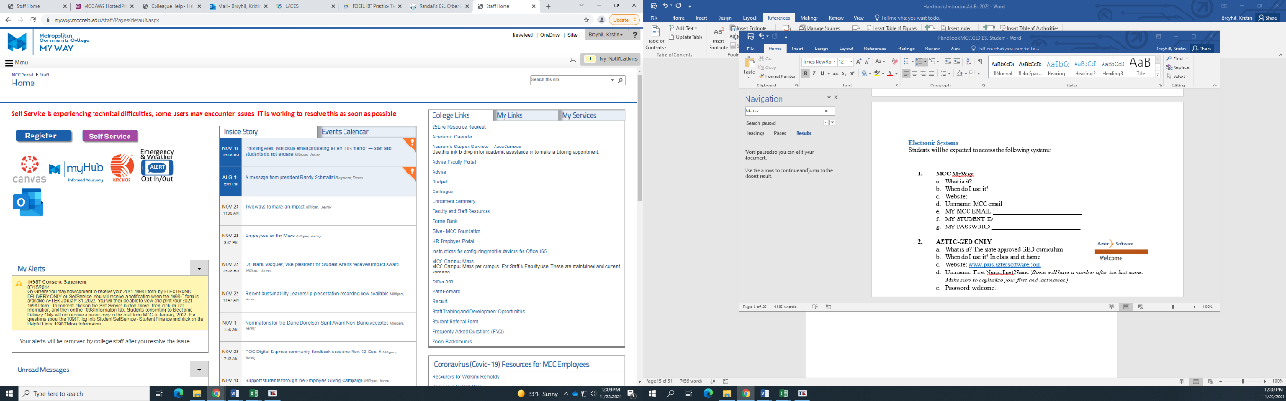
MCC MyWay
- What is it? MCC’s Main webpage
- When do I use it? Check it every day for messages and updates
- MCC Website
- Username: MCC email address
- Students use MCC email for all MCC correspondence – Please remember your password.

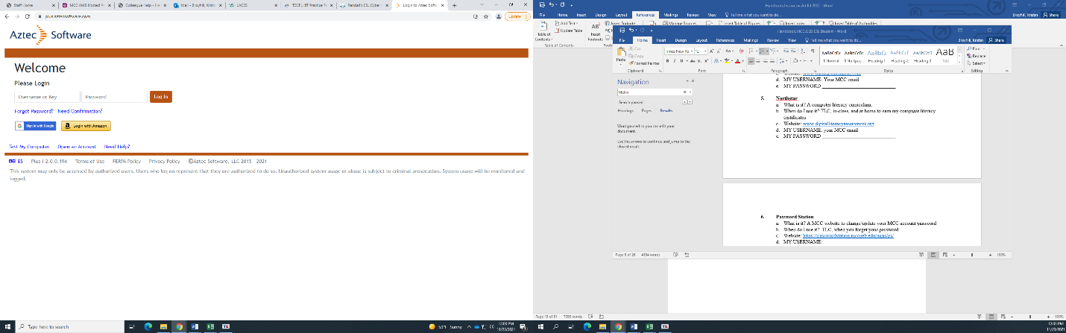
AZTEC-GED ONLY
- What is it? The state-approved GED curriculum
- When do I use it? In class and at home
- Aztec Website: plus.aztecsoftware.com
- Username: First Name.Last Name (Some students will have a number after the last name. Make sure to capitalize your first and last names)
- Password: welcome1

GED.com
- What is it? To practice the GED tests, register for tests, and access your scores.
- When do I use this? Once you are preparing for the GED.
- GED.com Website
- Username: You create this, this is NOT a MCC account, so you need to remember this
- Password: You create this, this is NOT a MCC account, so you need to remember this

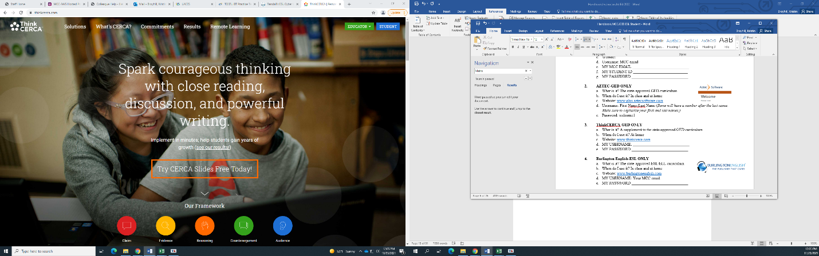
ThinkCERCA - (GED Students only)
- What is it? A supplement to the state-approved GED curriculum
- When do I use it? While studying for the GED
- ThinkCERCA Website
- Create a username and password for this site.


Burlington English- (ESL Students only)
- What is it? The state-approved ESL/ELL curriculum
- When do I use it? In class and at home
- Burlington English Website
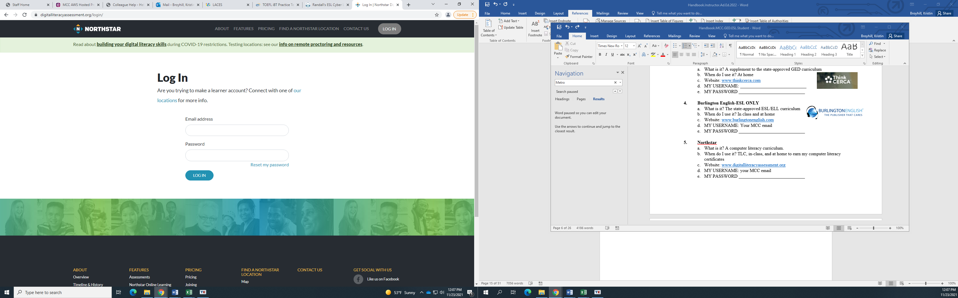
- MY USERNAME: MCC email address.

NorthStar
- What is it? A computer literacy curriculum.
- When do I use it? TLC, in-class, and at home to earn my computer literacy certificates
- NorthStar Website
- MY USERNAME: your MCC email

Password Station
- What is it? A MCC website to change/update/reset student MCC email account password
- When do I use it? To change/retrieve password.
- Password Station Website
- MY USERNAME: Choose a username
- MY PASSWORD: Choose a password

- ANSWERS TO MY 3 SECURITY QUESTIONS

MCC Sessions and Class Schedules
MCC’s Adult Education program has two class sessions:
- January through June
- July through December
ESL and GED Classes are held morning and evening and are available 5 days a week.
- Monday & Wednesday, 9:00 am – 12:00 pm
- Monday & Wednesday, 6:00 pm – 9:00 pm
- Tuesday & Thursday, 9:00 am – 12:00 pm
- Tuesday & Thursday, 6:00 pm – 9:00 pm
- Saturday, 9:00 am – 1:00 pm

Calendar for Adult Education 2022
- Term 1: Winter/Spring
  - January 10 – June 25
  - No classes held on the following dates:
    - January 17
    - April 16 – 17
    - March 7 – 12
    - May 23 – May27
    - May 30
- Term 2: Summer/Fall
  - July 11 – December 22
  - Breaks: TBA
*On days there are no classes, there will be no CASAS or GED testing.

Special Program Schedules

Computer Literacy Classes
MCC offers computer literacy classes for students and community members. These are free for you as well as your family & friends.

NorthStar Computer/Digital Literacy Classes
Schedule for January to June 2022 (July-December, schedule to be determined)
South Express  Campus: Room 104 |  | North Express  Campus: Room 312 |  | Online
Mondays | 12:00 pm - 12:45 pm | Tuesdays | 9:00 am – 12:00 pm | Fridays | 9:00 am – 12:00 pm
 | 12:45 pm – 1:30 pm | Thursdays | 9:00 am – 12:00 pm |  | ZOOM LINK
 | 6:00 pm – 6:45 pm
 | 7:00 pm – 7:45 pm
Wednesdays | 12:00 pm – 12:45 pm
 | 12:45 pm – 1:30 pm
South Express and Online
Bob Nikunen
Email: rdnikunen@mccneb.edu
Phone: 531-622-4060

North Express
Scott Jordan
Email: srjordan@mccneb.edu
531-622-5000

GED Program
MCC Adult Education provides curriculum to assist eligible students in completing the General Education Development (GED) diploma.
Obtaining a GED can open many doors for adult learners:
- Job Opportunities
- Counts as Vocational Job Training
- Furthering Education
- Self-esteem and self-confidence
MCC’s Adult Education faculty and staff are dedicated professionals who care about students and are committed to helping adult learners meet and exceed their goals.

Testing Requirements of the GED Program:
CASAS is free placement and progress testing for the program. CASAS tests are given when a student enters the program to determine learning levels, and every 40 hours by adding both classroom and online study hours. There are 6 Levels of CASAS tests (1-6), in both Math and Reading. Once a student reaches CASAS Level 6, they are eligible to begin GED Readys to prepare for the GED exam. Completing CASAS is a requirement of the GED program. CASAS also helps the student learn how to test, and shows milestones made by the student as they work toward the GED diploma.

CASAS Levels are also dependent upon eligibility. If a student does not attend for 90 or more days, they may be asked to CASAS test to enroll again. Absences of 6 months or longer require new CASAS tests, regardless of level. More can nbe learned at CASAS.org


How CASAS testing works
CASAS Subject | How often will I test? | When am I Done with CASAS? | What happens if I don’t take the CASAS tests? | Once I reach CASAS Level 6 what GED Readys can I take?
Reading | Every 40 Hours | Level 6 | At 50 Classroom Hours  - Student cannot attend classes  - Academic accounts such as Aztec will be suspended  - No new enrollments  - No GED vouchers issued  - Possible release from program | - Social Studies  - Reading Language Arts
Math |  |  |  | - Science  - Mathematics
CASAS testing allows the student to see academic progress as they attend class, with no negative consequences. These free tests will help determine what to study, how often to study, and identify areas of improvement. Results will be emailed to both students and their instructors so they can review the together and create plans to meet the student’s goals. CASAS scores do not negatively affect a student’s academic standing.

If a student fails to test promptly, every 40 hours, their access and participation in the program will be suspended and evaluated once they reach 50 hours.

GED Ready
This is a free practice GED test to determine if a student is likely to pass the official GED. There are 4 types of GED Ready tests: Reading Language Arts (RLA), Math, Social Studies, and Science. Once a student has completed CASAS, they can schedule these GED Ready tests with the help of their MCC Instructor(s). The passing score on a GED Ready is 145.

Students usually do better when pairing similar Ready exams: e.g., Math with Science and Social Studies with RLA. Once a student has earned a 145 in a subject, they can request to take a corresponding GED exam for free.

GED Official
The official GED test consists of 4 subjects: Reading Language Arts (RLA), Math, Social Studies, and Science. Students may schedule this test on GED.com. A passing score is 145 in each subject. If you earn a 165 or higher, you are considered college ready in that subject.
Please see GED Voucher information to learn more about MCC’s free GED program.

GED testing runs on a Program Year (PY), from July 1 to June 30. GED Readys taken in one program year (e.g., July 1 – June 30, 2022) must be retaken if the GED is not earned before June 30. If a student enrolls to complete their GED for the PY23 year after July 1, 2022, Ready tests will be administered again.

ESL Program
The English as a Second Language program at MCC Adult Education offers non-credit courses that help English learners develop the language and academic skills needed for success. Adult learners can then go on to earn a General Education Development diploma or GED.
MCC’s ESL Instructors are experienced professionals, dedicated to teaching English as a second language to adult learners at all levels of skill.

Requirements of the ESL Program:
English as a Second Language or ESL students are required to take CASAS tests:
CASAS is free placement and progress testing for the program. CASAS tests are given at the beginning of the program and every 40 hours by adding both classroom and online study hours. There are 6 Levels of CASAS tests (1-6), in both Listening and Reading. Once a student reaches CASAS Level 6 with a corresponding mastery score, they are eligible to begin the GED program for the GED exam. Completing CASAS is a requirement of the ESL and GED programs. CASAS also helps the student learn how to test, and shows milestones made by the student as they work toward mastery of their English skills.

How CASAS testing works
CASAS Subject | How often will I test? | What happens if I don’t take the CASAS tests? | When will I finish CASAS testing? | What happens when I Complete CASAS ESL?
Reading Levels 1-6 | Every 40 Hours (Student will receive a notification email from the Testing Coordinator) | At 50 Classroom Hours  - Student cannot attend classes  - Academic accounts such as Aztec will be suspended  - No new enrollments  - No GED vouchers issued  - Possible release from program | Level 6 with a score of 236 | Student may take GED placement CASAS and begin GED track with Instructor recommendation.
Listening Levels 1-6 |  |  | Level 6 with a score of 228 | Student may begin GED track once Reading is complete but will still test in Listening until score of 228 is reached.

Accelerated GED Program
Eligible students can enroll into the Accelerated GED Program. Students in this program can complete their GED within 12 months. Please contact the GED Facilitators for more information.
Bob Nikunen
- Email: rdnikunen@mccneb.edu
- Phone: 531-622-4062
Karen Dean
- Email: kldean@mccneb.edu
- Phone: 531-622-4052
Students may also work with their instructor to be recommended Accelerated GED Program if the student meets requirements. For more information, students should reach out to their instructors.
Many Accelerated GED Program students will continue to a specialized training program. Students may enroll into an accelerated GED program that combines GED and a skills training program.

Learning Labs
For additional practice or help, students can be enrolled in a second class. For GED these are called Learning Labs.
For more information on Learning Labs, please contact a GED Program Facilitator.

Training—MCC’s Integrated Education and Training Programs (IET)

Once a GED is obtained, MCC offers career programs in high-need and highly skilled industries. Some students may qualify to attend these courses for free.
The following IET programs are offered to students ready to gain work knowledge and find lasting employment.
- Hard Hat in Hands – Construction
- Sheet Metal Program
- Automotive Express Lane Certificate Program
- Pharmacy Technician
- Veterinary Assistant
- Facilities Maintenance
- Fiber Optics Technician
- CDLA with E Restrictions
- Medical Services Representative

IET Program Contacts
Coordinator for Integrated Education and Training-TBD
- Email:
- Phone:
IET Facilitator-Sheila Keller
- Email: skkeller@mccneb.edu
- Phone 531-622-4070

Advanced ESL
Students who meet the requirements for Advanced ESL will use both Burlington English and the GED AZTEC curriculum, AZTEC to learn higher-level English.
For more information about this program contact the ESL Facilitator.
ESL Program Facilitator-Kristin Broyhill
- Email: kbbroyhill@mccneb.edu
- Phone 531-622-2893

Language Labs
For additional practice or help, students can be enrolled in a second class. For ESL these are called Language Labs.
For more information on Language Labs, please contact the ESL Program Facilitator.


Open Enrollment and Class Registration
Registration for classes is held in May and November to enroll for the following term.
Students currently enrolled in MCC Adult Education will complete an online form during class with their instructor.
Enrollment Requirements for Current Students:
- Fill out the MCC Enrollment form
- Have a consistent attendance record
- All paperwork must be current, including NDE form and Release of Information
- CASAS Testing status must be current
If there are concerns about attendance, forms or testing a student may not be enrolled until speaking with a Program Facilitator or Adult Education Manager to determine if the program is a good fit for them at this time.
Once enrolled, students will receive a confirmation email at their MCC email address. Should a student not receive a confirmation email, they should contact Student Services at 531-622-4060 as soon as possible.
It is important to submit the correct information during enrollment. Before submitting the enrollment form, please double check all information, including:
- MCC email (MCC email addresses end in @mail.mccneb.edu)
- Full Name (use legal name, not a nickname)
- Student ID Number (this is a 7-digit number on your Student ID)
- Days and times of the classes requested (e.g., Monday and Wednesday 6:00 pm – 9:00 pm
- Location of the class requested (e.g., Fremont, online, or in-person at MXS)

If a student requires additional help enrolling, contact a Program Facilitator or Student Services.

Late Enrollment
Students who miss enrollment deadlines may be admitted during a period of late enrollment. This will generally the week before classes start. Students asking to enroll late may not receive the time, date, or instructor they want as seats have been filled. Enrollment is at the discretion of the Adult Education Manager. To enroll late, contact a Program Facilitator.

Transferring Courses
If a student needs to transfer from one course to another, they must contact their instructor with the reason(s) why the transfer is needed.
Please provide the instructor with the following information:
- Student’s Full Name
- Student MCC email
- Student ID Number
- Class transferring from
- Class desired to transfer to
Not all transfers can be approved. If the transfer is approved, it may take up to two weeks to complete the process and enter the new class. Students will be notified by MCC email when a decision is made. While waiting for the email confirmation, the student should continue class and online curriculum.
Transfers can be made:
- Winter/Spring: From February 1 to May 7
- Summer/Fall: From August 1 to November 5
Transfers may be denied under the following conditions
- Transfers are too frequently made/requested
- Poor attendance
- Outstanding CASAS test
- MCC is in an enrollment period
- Requested class is full

The Adult Education Manager will determine eligibility for transfers.
Students who want to take additional classes can request to sign up for a Language Lab (ESL) or Learning Lab (GED) in addition to their normal ESL or GED class.

Attendance Policy
Students must attend class regularly. A student will be disenrolled from their GED or ESL class and reassigned to a Learning Lab or Language Lab Course (LLC) if they:
- Fail to attend the first 4 class sessions
- Cannot complete 12 classroom/online study hours of class during the term
- Are absent 90 consecutive calendar days without cause
SITUATION | RESULT | STUDENT ACTION
Work or personal circumstances are too difficult to overcome to attend class | Student can withdraw from class | Contact Instructor or Program Facilitator to make arrangements to withdraw with the intent to return at a later date
Illness/Injury (self/family) | Student can withdraw from class | Contact Instructor or Program Facilitator to make arrangements to withdraw with the intent to return at a later date
Student has missed 3 or more consecutive weeks of class without communication with their instructor | Student will be dropped from classes and transferred to Learning or Language Lab | Student must enroll again at a later date with approval of the Adult Education Manager
Student has not attended class for over 90 days | Student will be dropped from classes and transferred to Learning or Language Lab or may be released from the program | Student may re-enroll and meet with the Adult Education Manager to discuss enrollment and attendance in the program

Attendance Verification for In-person Classes
A sign-in sheet is used for all classes. Students must sign in and out of classes to have their hours counted toward participation.

Attendance Verification for Online/Zoom Classes
Online students must send an ‘exit’ email to AEattendance@mccneb.edu and their instructor(s) with the following information after each class
- Subject line: Class and Date (e.g., GED 2 Sept 21, 2021)
- Log in time
- Log out time
- Activity (example math exercises, reading exercises, AZTEC)
- Student’s Full Name (full legal name on MCC record)


How to Check Email
- Go to www.mccneb.edu and click ‘LOGIN (My WAY)’ on the top of the webpage.

- At the log-in site, type your username (first part of your MCC email address, e.g., mmouse@mail.mccneb.edu “mmouse”) and password.
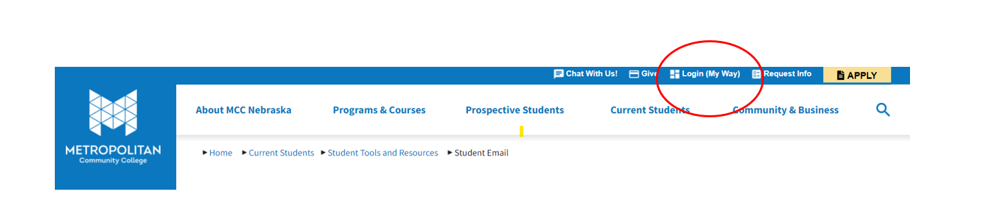
- On the homepage (which may look a little different than the one below), under “COLLEGE LINKS” click “OFFICE 365”. Office 365 is also located in the lower-left part of the screen.

- You may have to log-in again, this second log-in connects MyWay with Office 365.
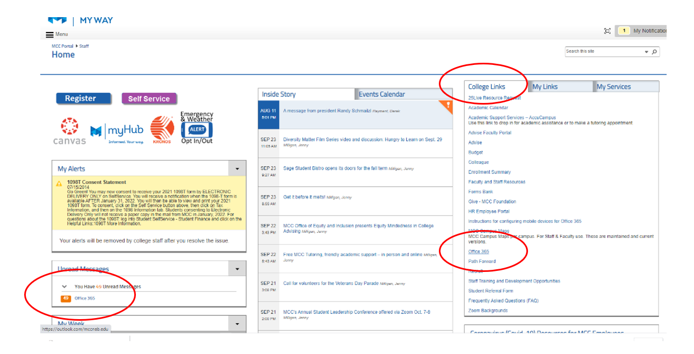

Testing – Scheduling a Test

How to Book a CASAS Test
Students must reserve a time to test through the link below or call MCC Student Services at (531) 622-4060.
CASAS TEST LINK
Make sure to reserve a time at least 24 hours ahead.
- Click the link above, or copy/paste it into a web browser (ex: Google Chrome).
- Select if you want a REMOTE or ON-SITE Test.
If you select remote, you must have a Windows PC. Chromebooks, iPads, and mobile phones are not used.
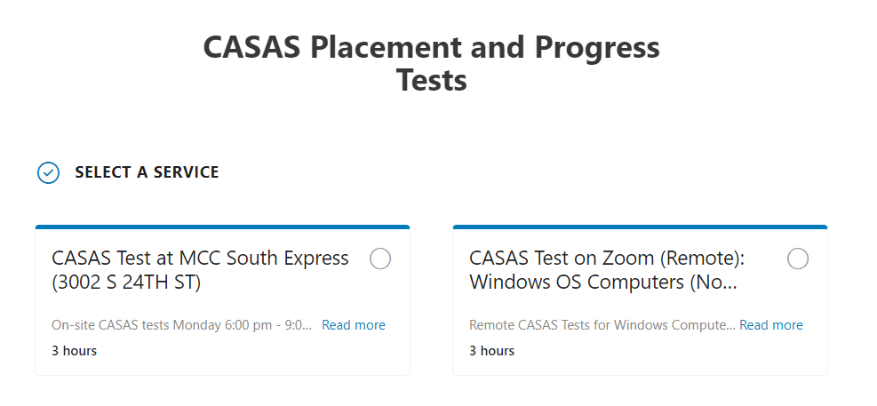

- Scroll down to select the day/time you will test.

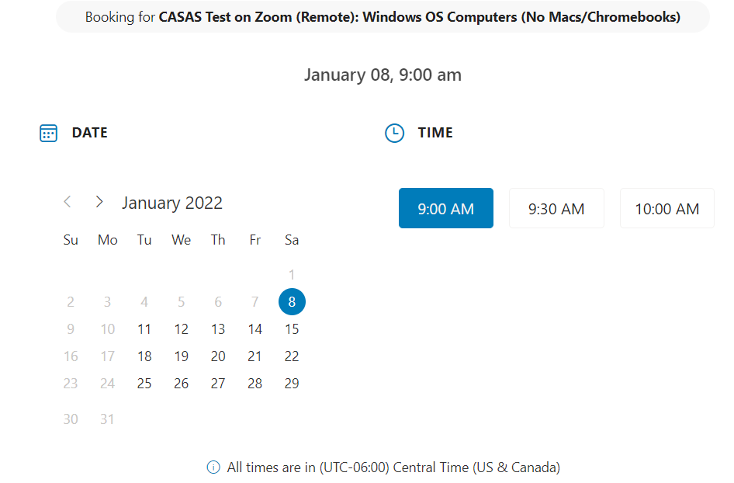

- Scroll down to enter in your first and last name as it is on school records, your MCC email, and your phone number.
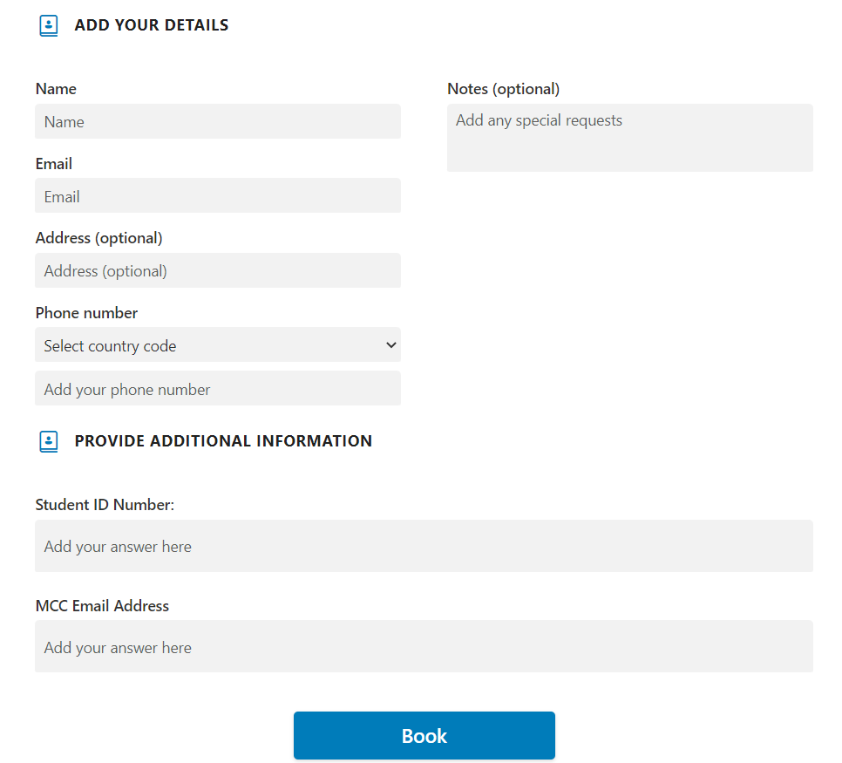

- Click Book.
- Check your MCC email for a confirmation email. Verify you selected the correct day, time, and mode (on-site OR remote).
On-site testing is always at Metro South Express (MXS) at 24th and Vinton Streets
If you requested a remote test AND you did not get a Zoom link emailed to you at least 30 minutes before the test, please contact Student Services at 531-622-4060 or email the Testing Coordinator.

CASAS FAQ
Q. Does CASAS affect my GED scores?
A. No. CASAS Tests are separate from your GED scores and will not affect them.

Q. What happens if I “fail a CASAS test?
A. You cannot fail a CASAS. If your score is too low or too high to be measured, you will retake the test either right away or when you reschedule to come back. These appear as a --, *, or ♦ instead of a number score.

Q. My score went down. Does that mean I am not learning?
A. Scores can go up and down for many reasons. It is best to schedule CASAS tests when your mind is rested and you can focus. A lower score does not always mean you did not make an educational gain.

Q. Can I CASAS test any time I want to track my progress?
A. No. CASAS tests cannot be taken if a student has less than 40 hours in the classroom and online learning.

Q. How will I know when I need to test?
A. The Testing Coordinator will email you and may email your instructor to remind you to schedule.

Q. I have a disability. Will I have accommodation when I test?
A. Only your instructor knows if you have accommodation, such as increased time or a large screen. MCC will accommodate your disability. Please make sure the test proctor knows to give it to you. Accommodations must be in writing from a qualified medical professional and cleared through MCC.

GED Vouchers:
If need assistance in paying for your GED tests, please talk with your instructor.
To qualify for free GED Ready or Official Vouchers, you must.
- Have all paperwork current
- Have earned a minimum of 12 instructional hours within the current program year (July 1-June 30).
- Have a current CASAS test (less than 40 academic hours accrued)
- Earned CASAS Level 6 in said subject area.
- Have a GED.com account (this is not managed by MCC).
- For GED Official vouchers you must have scored a 145 or higher on the GED Ready test in the same subject as the official test.
- Work with your instructor to fill out the voucher request forms.

Taking the GED Test
To take the Official GED, please schedule your appointment as soon as possible. You must test in-person for the GED OFFICIAL test(s), and there are limited times and locations in the Omaha area.
You have 30 days from taking the Ready to take the Official. If you cannot schedule an Official test within 30 days of taking the Ready, you may need to re-take that GED Ready test to restart your 30 days.
If you miss your GED Official appointment, you will need to wait another 60 days before you can take another test.
You can only schedule tests through your GED.com account.

After GED Testing

What to do After Program Completion
Once you complete your GED program you have many options
- GED/ESL: Continuing to an academic program at MCC (or another university)
- GED/ESL: Continuing to an Integrated Education and Training (IET) program at MCC
- ESL Continuing on to a GED program if you need a high school diploma.
- ESL: Acquiring more academic language at MCC with for-credit or adult educational classes
ESL Students may speak to the ESL Facilitator about options following ESL Completion.

Continuing with MCC to an Accredited Academic Program
If you would like to continue to an academic program, please contact an Advisor/Navigator.
MCC will help you find a good academic program and will assist with enrollment in an MCC degree program.
Advisor/Navigator - Stacey Mapp
- Email: sjmapp@mccneb.edu
- Phone: 531-622-2662
Advisor/Navigator – Anna Somers
- Email: assomers496@mccneb.edu
- Phone: 531-622-2136
If you do not require advising services, and wish to enroll at MCC for credit college classes, follow these steps:
- Schedule an English placement exam with the MCC Testing Center
- Students going into an academic (non-ESL) program will take the “Write Placer Test”
- Students going into for-credit ESL courses will take the “ESL AccuPlacer”
- Contact a testing center at a nearby MCC campus: MCC Testing Centers
On behalf of the entire Adult Education staff, welcome to Metropolitan Community College. We look forward to meeting with you and working with you this year. As a faculty, we are committed to providing a quality education to all our adult learners. We consider each student as a unique individual and strive to meet their needs. We endeavor to provide a solid foundation to succeed in the workforce, through quality instruction from specialists in Adult Education. Our curriculum and instructional practice build skills and thinking strategies that will empower students to be independent and successful throughout their lives. Just as important as building a strong academic foundation is the formation and strengthening of community. Students are encouraged to be responsible and fully engaged in their own learning.


Inclement (Bad) Weather and Campus Closures
Please sign up for MCC’s bad weather and campus closures notifications through MyWay, by clicking on the Emergency & Weather Alert Opt In/Out icon. During bad weather, all campuses will be closed (except possibly Fremont), but if it’s a campus closure, for example an electrical issue, only that one campus will be closed.
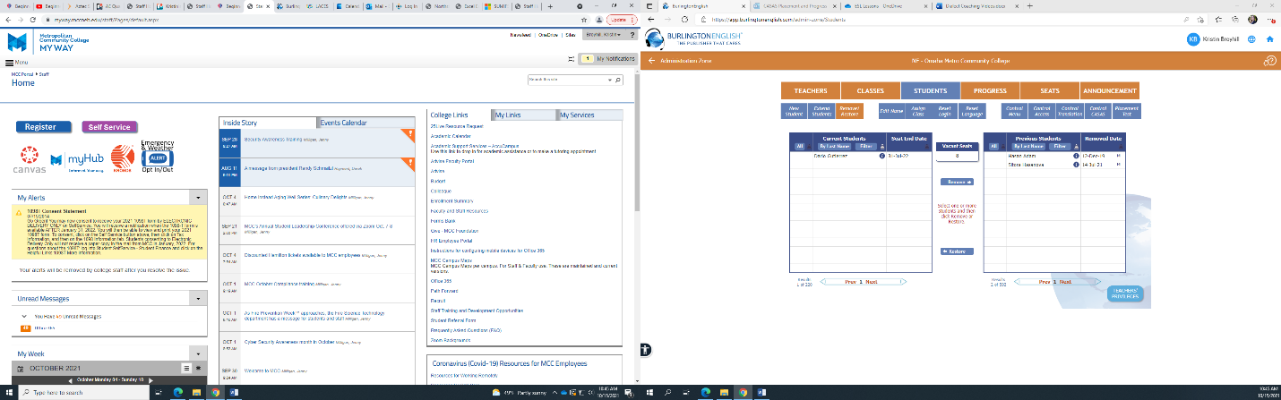
Students can also go to www.mccneb.edu to see if there are any closures. An announcement will appear on the top of the page.
PLEASE NOTE: If there are closures due to bad weather, online (ZOOM) courses are also cancelled.
If classes are not cancelled, but you are unable to get to class (ex: icy roads), please contact your instructor as soon as possible.

Disability/Accessibility Services
MCC Disability Services can help students with a physical, mental, and/or learning disability. They have connections to community resources as well.

South Campus
- Elizabeth Perez, DSS Counselor
- Phone: 531-622-4757
- Email: eperez15@mccneb.edu

Fort Omaha Campus
- Ryan Stamm, DSS Counselor
- Phone: 531-622-2766
- Email: restamm@mccneb.edu

Laptop or Hotspot Loaner Program
Students to do not have access to a computer and/or internet, may qualify for the Laptop and Hotspot Loaner Program.
To qualify, you must be enrolled in a class and have good attendance.
If you need help, please ask your instructor or call student services 531-622-4060.
Students must return laptops and/or hotspots when not enrolled in a class.

Pass to Class--Free Bus Ride Program
MCC students may qualify for the Pass to Class program.
You can also use this pass to ride the bus for any reason, such as going to work.
To register for this program, contact Student Services at MCC’s South Express campus.
You will need to renew this pass 4 times a year (December, March, June, September).

Career Services
Career Services can help you with job interviews, job searching, networking, creating resumes, cover letters, and help with job searches. Call 531-622-4647 for more information.
To understand what career would fit you best, take this MCC Career Assessment.

MCC Tutoring Center

MCC Language and Literacy Center

MCC Math Center

Frequently Asked Questions

Should I take an in-person or remote class?
It is generally advised to take in-person classes if possible. However, we realize that some individuals are unable to travel to an onsite location for work, transport, or family reasons. If you take online courses, please make sure that you have a good internet connection and are patient with the instructor, as you may get less one-on-one time with the instructor due to the online environment. Remote classes take place over Zoom and your instructor will have a specific link for you to use during the term.

I have a busy work schedule and family; can I just attend classes once a week?
No. If you are enrolled in a class, you are expected to attend all class sessions (unless for example, you are sick or you will be out of town). Most classes are twice a week. If this is not possible for you, Open Learning Opportunities such as Learning Labs for GED students and Language Labs for ESL students allow more flexibility.

If you do not consistently attend class, your seat may be given to a new student and you may be transferred to a Language or Learning Lab.
For more information, please see our attendance policy.

Where do I find jobs or training programs?
After you complete your GED and/or ESL program, MCC’s Integrated Education and Training Program has a number of courses for high-need, high-wage industries. Please see the Training Section above.

What score do I need to pass ESL?
When you get a score of 236 in reading AND a 228 in listening on your CASAS test, you pass ESL. You must pass both reading AND listening to complete the program.
If you want to move onto college, you will have to take a TOEFL test, but we would suggest you take additional ESL classes to prepare for college-level English skills.
For more information on MCC ESL testing, please see Progress Testing.
Here is more information about ESL for-credit courses at MCC

Do I have to pay for tests?
No. All CASAS (progress) testing is for free and required to continue in your program.

What score do I need to pass my GED? Is the GED one big test?
You need CASAS Level 6 on Math or Reading GED subject to take a GED Ready test.
In the GED Ready test, you must score a minimum of 145 to take the GED Official test in that subject. A GED Ready test is simply a test that MCC requires you to take to estimate the likelihood you will pass your GED Official test.
You need a 145 on the GED Ready to pass the GED Official test for each subject (Social Studies, Science, Math, RLA). Once you pass each of the 4 tests, you will earn your GED. If you earn a score of 165 or higher on any one test, that indicates you are ready for college in that subject. You can select which test you choose to take first.

What test score is ‘college ready’ for a GED/ESL?
For GED, a subject test score of 165+ means you are college ready in that subject.
For ESL, most colleges are looking for a minimum for 60 on the computer-based TEOFL test (or equivalent). Some colleges require that no sub-score on any of the 4 tests (reading, writing, speaking, listening) is below a certain number (for example, 15).
Here is information about the TOEFL test: https://www.ets.org/toefl/test-takers/ibt/take/locations-dates/

Are GED Classes like high school classes?
Not exactly, classes are generally much smaller be it remote or in person. Most students work at their own pace with instructors there to aid as needed. Because students are not together in a classroom it will take a lot of self-discipline to complete the work. If a student is not able to attend classes or dedicate the time needed to learn the material they may look into open learning options where attendance is not required. For open learning opportunities, please contact the GED Facilitator.

Can I bring my children?
No. Children are not allowed to attend a course, or be unattended in the building, while you are in class.

Can I bring a family member or friend to ‘try out’ a class?
No. If you have a friend or family member interested in taking classes, please contact the Transitionary Learning Center (TLC) within the Adult Education Department at: adultedu@mccneb.edu or Contact Student Services at 531-MCC-4060. If someone who is not enrolled in a course attends with you, they will be asked to leave.

Is there a place to help with my English conversation skills?
MCC offers students additional practice through a Language Lab. For more information, please contact your instructor.

Can I bring my emotional support animal?
Please contact disability and accessibility services for more information on your unique situation.

If I can’t get a hold of my instructor, who should I contact?
If you cannot get ahold of your instructor, contact your Program Facilitator.

Is there a graduation ceremony?
Before COVID-19, there was a graduation ceremony in September. We will inform students when we can do this again.

What supplies do I need?
For online courses, you will need a computer and reliable internet access. If you do not have a computer and/or internet, please look at our Laptop Loaner Program. For on-campus students, you just need to be able to attend class regularly.

Please note that changes in the Adult Education department happen often and may not be reflected in this handbook. Changes in policy and procedure may happen without warning but will be communicated with the appropriate parties as soon as possible.

